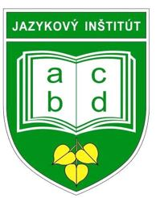 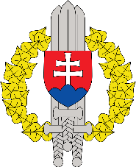

**International English Language Conference**

**Liptovský Mikuláš, SLOVAKIA**

**3 – 5 June, 2024**

**“AT EASE 2024”**

**PERSONNEL ADMINISTRATION FORM**

Please fill out the Registration Form and email it via your national POC to the Host Nation POC Peter Špiner [peter.spiner@mil.sk](mailto:peter.spiner@mil.sk) no later than May **10, 2024**.

**Delegate:**

|  |  |
| --- | --- |
| Country: |  |
| First Name(s): |  |
| Last Name(s): |  |
| Rank/Title:  (this will be written on the certificate in front of your name) |  |
| Organization & appointment: |  |
| Phone: |  |
| E-Mail: |  |

**Travel details:**

|  |  |
| --- | --- |
| Arrival time & date |  |
| Means of transport |  |
| Departure time & date |  |
| Means of transport |  |

**Head of Delegation:**  **OR** **Delegation Member:**

**Participation**

This language conference brings together language teachers, interpreters, terminologists, translators, managers and other language experts from NATO and partner nations to discuss topics of interest, new developments and technology in the area of teaching, testing and managing of military language institutes. The goal of the conference is to initiate management discussions, interoperability, and security, as well as capability aspects, and challenges / methods / techniques when teaching intensive and specialized foreign language courses.

**We, therefore, encourage you to submit a proposal to give a presentation, conduct a workshop, or present a digital poster on the topic of your interest as suggested in the Joining Instructions.**

**The options are:**

1. Presentation on any of the suggested topics (see Joining Instructions) or relevant topics (30 minutes)
2. Workshop (You would conduct a workshop exploring the topic you have chosen) (60-90 minutes)
3. Digital poster (You would prepare a digital poster with information and ideas on the topic you have chosen, and participants will be able to ask you questions about it) (10 minutes)

In the box below, please select the activity type, and write its title and a short description.

**Activity Type**

**Presentation**

**Workshop**

**Digital poster**

**Title:**

**Description:**

**Additional Information:**

Please provide any other information which may be useful to the Seminar planners (e.g. dietary restrictions, allergies (note: please include specific food allergies) special requests, or physical accommodations).

|  |
| --- |
|  |

**We particularly encourage you to participate in this new event with your contributions in PRESENTATIONS / DIGITAL POSTERS / WORKSHOPS. Without them we can't have the succesfull Conference.**

**We would also like to hear what issues related to teaching / translating / interpreting / managing are of your interest because our intention is to have discussion groups for sharing our experiences and helping each other improve our skills.**